Internet Of Things Project Report

**Abstract:**

The Smart Door Lock project is a home security solution designed to provide convenient and secure access control using Arduino Uno and a keypad. This project addresses the limitations of traditional key-based locks by offering a keyless entry system that relies on a user-defined code. By utilizing an Arduino Uno microcontroller, the system can efficiently process keypad input and control the locking mechanism, ensuring reliable and accurate operation.

The core functionality of the Smart Door Lock is based on the interaction between the keypad, Arduino Uno, and the locking mechanism. When a user enters the correct code on the keypad, the Arduino Uno processes the input and triggers the unlocking mechanism, allowing the door to be opened. This eliminates the need for physical keys, making it easier for users to access their homes while enhancing security.

To enhance user experience, the Smart Door Lock features an LCD display that provides feedback to the user, such as indicating when the correct code has been entered or displaying error messages for incorrect inputs. Additionally, a buzzer is included to provide audible notifications, ensuring that users are aware of the system's status.

The Smart Door Lock project offers a cost-effective and efficient alternative to traditional locks, providing a customizable and secure access control solution for homes. By leveraging the capabilities of Arduino Uno and a keypad, this project demonstrates how modern technology can be used to enhance home security and convenience.

**Introduction:**

The Smart Door Lock project represents a significant advancement in home security, leveraging Arduino Uno and a keypad to create a keyless entry system with enhanced security features. Traditional locks, while effective, are vulnerable to issues like key duplication and lock picking. The Smart Door Lock addresses these vulnerabilities by providing a keyless entry system that relies on a user-defined code for access.

A key security feature of the Smart Door Lock is its ability to resist unauthorized access. Users can define a unique access code, which can be easily changed to maintain security. In the event of an unauthorized attempt to access the door, a buzzer integrated into the system will sound, alerting the user and potentially deterring intruders.

The project also includes an LCD display to provide visual feedback, ensuring that users are aware of the system's status. This combination of security features offers users peace of mind and confidence in the security of their homes.

Furthermore, the Smart Door Lock project demonstrates how modern technology can be harnessed to enhance home security. By combining Arduino Uno with a keypad and a buzzer, this project provides a reliable and effective solution for keyless entry, improving convenience while maintaining a high level of security.

**Project Description:**

The Smart Door Lock project is a sophisticated home security system that offers keyless entry using a keypad and advanced features. The system is built around an Arduino Uno microcontroller, which serves as the central processing unit. A servo motor is used to physically lock and unlock the door mechanism in response to the input from the keypad.

The keypad allows users to enter a predefined code to unlock the door. If the wrong code is entered, a buzzer integrated into the system will sound, alerting the user and potentially deterring intruders. An LCD screen provides feedback to the user, displaying messages such as "Access Granted" or "Access Denied" to indicate the status of the system.

To ensure the system operates smoothly, resistors are used to manage the flow of electrical current and protect the components from damage. The Smart Door Lock project offers a high level of security and convenience, providing users with peace of mind knowing their homes are protected by a state-of-the-art security system.

**Key Functionalities:**

The Smart Door Lock project integrates various components to provide a comprehensive and secure keyless entry system for homes. With its key functionalities, the project enhances home security and user convenience.

**The keyless** **entry:** feature eliminates the need for physical keys, offering a more convenient and secure way to unlock the door. Users can simply enter a predefined code on the keypad to unlock the door, providing quick and easy access.

**The customizable access code** : feature allows users to define a unique access code that can be easily changed as needed. This adds an extra layer of security, as users can create a code that is easy to remember but difficult for others to guess.

**The audible feedback** :feature uses a buzzer to sound when an incorrect code is entered, alerting the user to the failed attempt. This helps deter potential intruders and provides the user with immediate feedback on the status of the lock system.

**The visual feedback** :feature uses an LCD screen to display messages such as "Access Granted" or "Access Denied," providing clear and informative feedback to the user. This enhances the user experience by ensuring that users are aware of the status of the lock system at all times.

**The tamper detection:** feature allows the system to detect and respond to tampering attempts. For example, the system can be programmed to trigger an alarm or lockout mechanism if multiple incorrect codes are entered, further enhancing security.

In conclusion, the Smart Door Lock project offers a range of key functionalities that enhance home security and user convenience. Its integration of various components provides a modern and effective solution for keyless entry, making it an ideal choice for homeowners looking to enhance the security of their homes.

**Methodology**:

The methodology employed in this project is designed to ensure a systematic and thorough approach to the development and implementation of the refrigerator control system. It consists of several distinct yet interconnected steps, each contributing to the overall success and effectiveness of the project.

1. Requirement Analysis:

- Conduct thorough interviews and discussions with homeowners to understand their specific security needs, lifestyle, and preferences.

- Identify key requirements such as the level of security desired, access control methods (e.g., keypad, RFID, biometric), integration with existing smart home systems, and any special features or functionalities desired.

- Document the requirements in detail, considering factors such as the number of users, access levels, remote access capabilities, and notifications/alerts.

2. Component Selection and Integration:

- Research and select appropriate electronic components based on the identified requirements and constraints.

- Choose a suitable Arduino board (e.g., Arduino Uno) as the central control unit for the door lock system.

- Select a servo motor to actuate the locking mechanism, a buzzer for audible feedback and alarm signals, an LCD for displaying system status and user prompts, and resistors for voltage regulation and signal conditioning.

- Ensure compatibility and reliability of selected components with the Arduino platform and each other.

- Design the physical layout and wiring configuration to integrate the selected components into the door lock system, considering factors such as space constraints, power requirements, and ease of maintenance.

3. Algorithm Development:

- Develop algorithms to manage the behavior of the door lock system based on input from sensors and user commands.

- Implement logic for functions such as user authentication, locking and unlocking the door, detecting and responding to intrusion attempts, and providing feedback to the user via the LCD and buzzer.

- Design algorithms to handle edge cases and error conditions, such as incorrect user input, communication failures, and power interruptions.

- Optimize algorithms for efficiency, responsiveness, and reliability, considering the limited processing power and memory of the Arduino board.

4. Arduino Programming:

- Write and upload code to the Arduino board using the Arduino Integrated Development Environment (IDE).

- Program the Arduino to interact with connected components, read input from sensors (e.g., keypad, RFID reader), execute control logic, and provide feedback to the user.

- Organize the code into modular and well-structured functions, with clear comments and error handling mechanisms.

- Test the code iteratively on the Arduino board, debugging and refining as necessary to ensure correct functionality and robustness.

5. Simulation and Testing:

- Utilize simulation tools such as Tinkercad or Proteus to simulate the behavior of the door lock system in a virtual environment.

- Conduct comprehensive testing to verify the functionality and performance of the system under various scenarios, including normal operation, user authentication, lock/unlock commands, alarm triggers, and error conditions.

- Validate the accuracy of sensor readings, the responsiveness of control actions, and the overall reliability of the system.

- Perform stress testing and edge case analysis to identify potential weaknesses or failure points and address them proactively.

6. Refinement and Optimization:

- Gather feedback from stakeholders, users, and testing results to identify areas for improvement.

- Iterate on the design and implementation to address any identified issues, optimize performance, and enhance user experience.

- Fine-tune parameters, adjust algorithms, and optimize code for efficiency and reliability.

- Incorporate additional features or enhancements based on user feedback and emerging technologies, ensuring that the door lock system remains up-to-date and responsive to evolving needs.

Software:

**Arduino IDE (Integrated Development Environment):** Used for programming the microcontroller to interact with sensors and actuators

**Schematic Diagram:**

Schematic view of project from thinker cad.

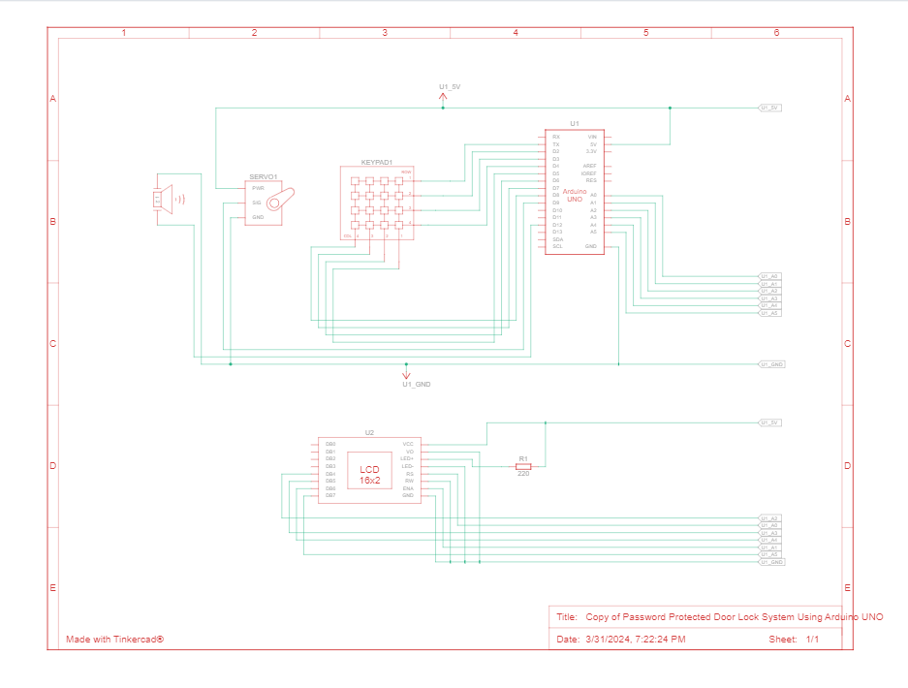

**Tinker cad:**

Implementation on software

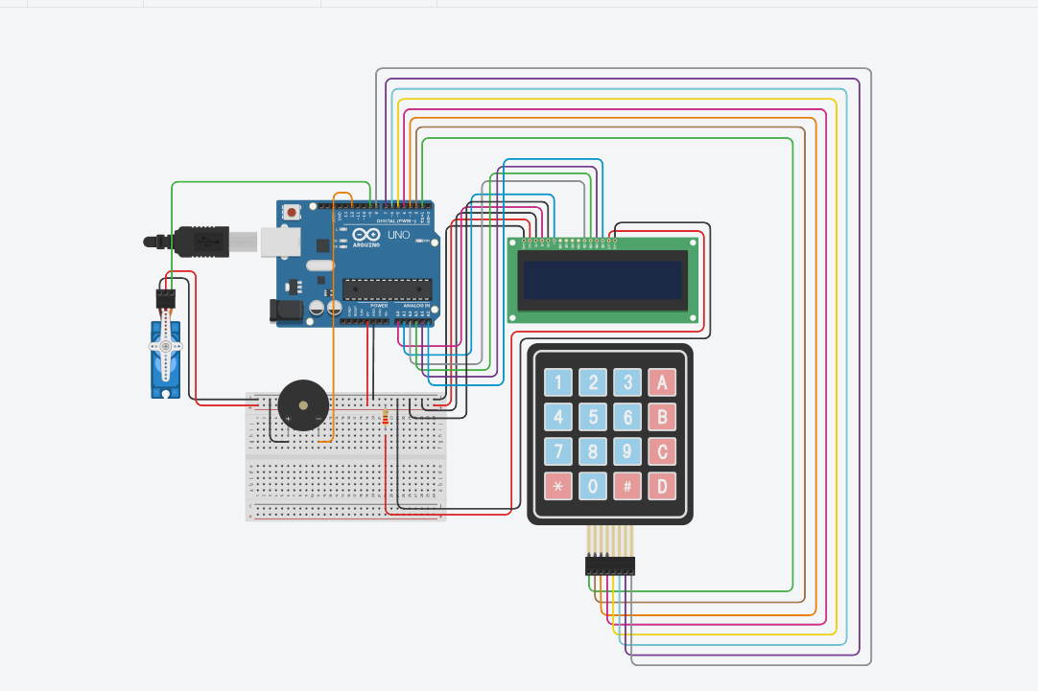

**Components**:

List of components that are used in the project

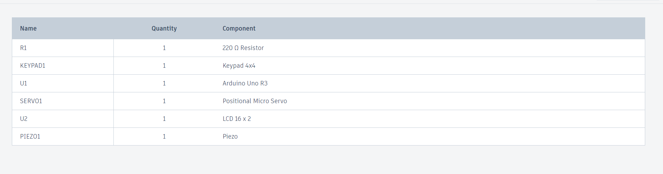

Arduino Microcontroller Board:

At the heart of the system lies the Arduino microcontroller board, serving as the central processing unit. It orchestrates the operation of the entire control system by processing sensor data, executing control algorithms, and interfacing with external components. The Arduino platform provides a versatile and user-friendly environment for developing embedded systems applications.

LCD Screen (e.g., 16x2):

An LCD screen is integrated into the control system to provide detailed information to users in a user-friendly format. The 16x2 LCD screen consists of two lines with 16 characters each, allowing for the display of alphanumeric text and symbols. It serves as a centralized interface for displaying real-time temperature readings, item quantities, and any alerts or notifications generated by the control system.

Resistors and Connecting Wires:

Resistors and connecting wires are essential components used in the circuitry to establish electrical connections and ensure proper signal transmission. Resistors are employed to limit current flow, protect components from damage, and maintain voltage levels within specified ranges. Connecting wires facilitate communication between the Arduino microcontroller, sensors, actuators, and other peripheral devices, enabling seamless integration and operation of the control system.

Piezo Buzzer:

The piezo buzzer is an audio signaling device commonly used in electronic projects to generate audible alerts, alarms, and tones. It consists of a piezoelectric element that produces sound vibrations when an electrical signal is applied to it.

In the context of the door lock system, the piezo buzzer serves as an auditory feedback mechanism to notify users of various events such as successful door access, invalid access attempts, system errors, or alarms triggered by unauthorized entry attempts.

When triggered by the Arduino microcontroller, the piezo buzzer emits distinct sound patterns or frequencies to convey different messages or signals to users, enhancing the overall user experience and security awareness.

Servo Motor:

A servo motor is a rotary actuator that allows precise control of angular position, velocity, and acceleration. It consists of a motor coupled with a feedback mechanism (e.g., potentiometer or encoder) to accurately position the motor shaft based on the input signal.

In the door lock system, the servo motor is utilized to physically actuate the locking mechanism of the door. It can rotate a shaft or lever to engage or disengage the lock, allowing for remote or automated control of access to the secured area.

The Arduino microcontroller sends control signals to the servo motor based on user commands or system logic, instructing it to lock or unlock the door in response to valid access attempts or other predetermined conditions.

Breadboard:

A breadboard is a fundamental prototyping tool used in electronics projects to create temporary electrical connections between components and circuits without the need for soldering. It typically consists of a grid of interconnected metal clips or sockets mounted on a non-conductive base.

In the development of the door lock system, the breadboard serves as a platform for assembling and testing the circuitry before final integration into a more permanent housing or enclosure.

Components such as the Arduino microcontroller, sensors, resistors, and connecting wires are inserted into the breadboard and interconnected as per the circuit diagram. This allows for easy experimentation, troubleshooting, and modification of the circuit design during the development process.

Keypad:

A keypad is an input device consisting of a set of buttons arranged in a grid or matrix format, typically used for entering numerical or alphanumeric data. Each button represents a specific character or function, and pressing a button generates a corresponding electrical signal.

In the door lock system, the keypad serves as the primary user interface for entering access codes or PINs to unlock the door. Users can input their unique code using the keypad, which is then processed by the Arduino microcontroller for authentication and access control.

The Arduino microcontroller reads the signals from the keypad buttons and interprets them to determine the entered access code. It compares the code against stored credentials or predefined codes to grant or deny access accordingly, activating the servo motor to unlock the door if the code is valid.

**Source Code:**

#include <Keypad.h>

#include <LiquidCrystal.h>

#include <Servo.h>

#define Password_Length 5

Servo myservo;

LiquidCrystal lcd(A0, A1, A2, A3, A4, A5);

int pos = 0;

const int buzzer = 8;

char Data[Password_Length];

char Master[Password_Length] = "1234";

byte data_count = 0, master_count = 0;

bool Pass_is_good;

bool door = false;

char customKey;

/---preparing keypad---/

const byte ROWS = 4;

const byte COLS = 4;

char keys[ROWS][COLS] = {

{'1', '2', '3', 'A'},

{'4', '5', '6', 'B'},

{'7', '8', '9', 'C'},

{'*', '0', '#', 'D'}

};

byte rowPins[ROWS] = {0, 1, 2, 3};

byte colPins[COLS] = {4, 5, 6, 7};

Keypad customKeypad( makeKeymap(keys), rowPins, colPins, ROWS, COLS);

void setup()

{

pinMode(buzzer, OUTPUT);

myservo.attach(9, 2000, 2400);

ServoClose();

lcd.begin(16, 2);

lcd.print("Protected Door");

loading("Loading");

lcd.clear();

}

void loop()

{

if (door == true)

{

customKey = customKeypad.getKey();

if (customKey == '#')

{

lcd.clear();

ServoClose();

lcd.print("Door is closed");

delay(3000);

door = false;

}

}

else

Open();

}

void loading (char msg[]) {

lcd.setCursor(0, 1);

lcd.print(msg);

for (int i = 0; i < 9; i++) {

delay(1000);

lcd.print(".");

}

}

void clearData()

{

while (data_count != 0)

{

Data[data_count--] = 0;

}

return;

}

void ServoClose()

{

for (pos = 90; pos >= 0; pos -= 10) {

myservo.write(pos);

}

}

void ServoOpen()

{

for (pos = 0; pos <= 90; pos += 10) {

myservo.write(pos);

}

}

void Open()

{

lcd.setCursor(0, 0);

lcd.print("Scan Fingerprint");

customKey = customKeypad.getKey();

if (customKey)

{

Data[data_count] = customKey;

lcd.setCursor(data_count, 1);

lcd.print(Data[data_count]);

data_count++;

}

if (data_count == Password_Length - 1)

{

if (!strcmp(Data, Master))

{

lcd.clear();

ServoOpen();

lcd.print(" Door is Open ");

door = true;

delay(5000);

tone(buzzer, 1000); // 1KHz sound signal

delay(1000); // ...for 1 sec

noTone(buzzer); // Stop sound...

delay(1000);

loading("Waiting");

lcd.clear();

lcd.print(" Time is up! ");

delay(1000);

ServoClose();

door = false;

}

else

{

lcd.clear();

lcd.print(" Wrong Password ");

door = false;

}

delay(1000);

lcd.clear();

clearData();

}

}

**Results / Outcome**:

The home intrusion detection system developed using Arduino has proven to be highly effective and beneficial, providing numerous positive outcomes:

I. Intrusion Detection:

The system effectively detects unauthorized entry or intrusion attempts into the home. Utilizing sensors such as passive infrared (PIR) motion sensors, door/window magnetic contact sensors, or vibration sensors, the system can detect movement or disturbances within the premises.

II. Real-time Alerts:

Upon detecting an intrusion, the system promptly generates real-time alerts to notify homeowners or authorities. These alerts can be in the form of audible alarms, SMS notifications, email alerts, or push notifications to mobile devices, ensuring timely response and intervention in case of a security breach.

III. Remote Monitoring:

The integration of wireless communication modules such as Wi-Fi or GSM enables remote monitoring of the home security system. Users can access real-time surveillance footage, sensor data, and system status updates from anywhere via a smartphone app or web interface, enhancing situational awareness and peace of mind.

IV. Deterrent Effect:

The presence of a visible home intrusion detection system acts as a deterrent to potential intruders. Knowing that the premises are equipped with surveillance cameras, motion sensors, and alarm systems, would-be burglars are less likely to attempt unauthorized entry, thereby enhancing home security and reducing the risk of break-ins.

V. Integration with Smart Home Ecosystem:

The intrusion detection system can be seamlessly integrated with other smart home devices and ecosystems. Integration with smart lighting systems, smart locks, and home automation platforms enables enhanced security features such as automated lighting control, remote door lock/unlock functionality, and integration with voice assistants for voice-controlled security commands.

VI. Customizable Security Zones:

The system allows for the customization of security zones or areas within the home. Users can define specific areas to be monitored more closely or armed/disarmed based on their preferences or occupancy patterns, providing flexibility and adaptability to different security needs.

VII. Backup Power and Redundancy:

Incorporating backup power sources such as batteries or uninterruptible power supplies (UPS) ensures the continued operation of the intrusion detection system during power outages or emergencies. Redundant components and failover mechanisms further enhance system reliability and resilience to faults or malfunctions.

VIII. User-Friendly Interface:

The system features a user-friendly interface, typically through a smartphone app or web portal, allowing users to easily configure settings, view security alerts, and manage the system remotely. Intuitive controls and clear visualizations enhance user experience and make interacting with the system effortless.

IX. Privacy Protection:

Robust security measures, such as data encryption, secure authentication protocols, and privacy controls, safeguard user data and prevent unauthorized access to sensitive information. Compliance with privacy regulations and best practices ensures that user privacy is respected and protected at all times.

X. Community Security Collaboration:

Integration with community-based security networks or platforms enables collaboration with neighbors and local authorities in monitoring and responding to security incidents. Shared alerts, neighborhood watch features, and collaborative incident reporting foster a sense of community security and cooperation in combating crime.

Without running:

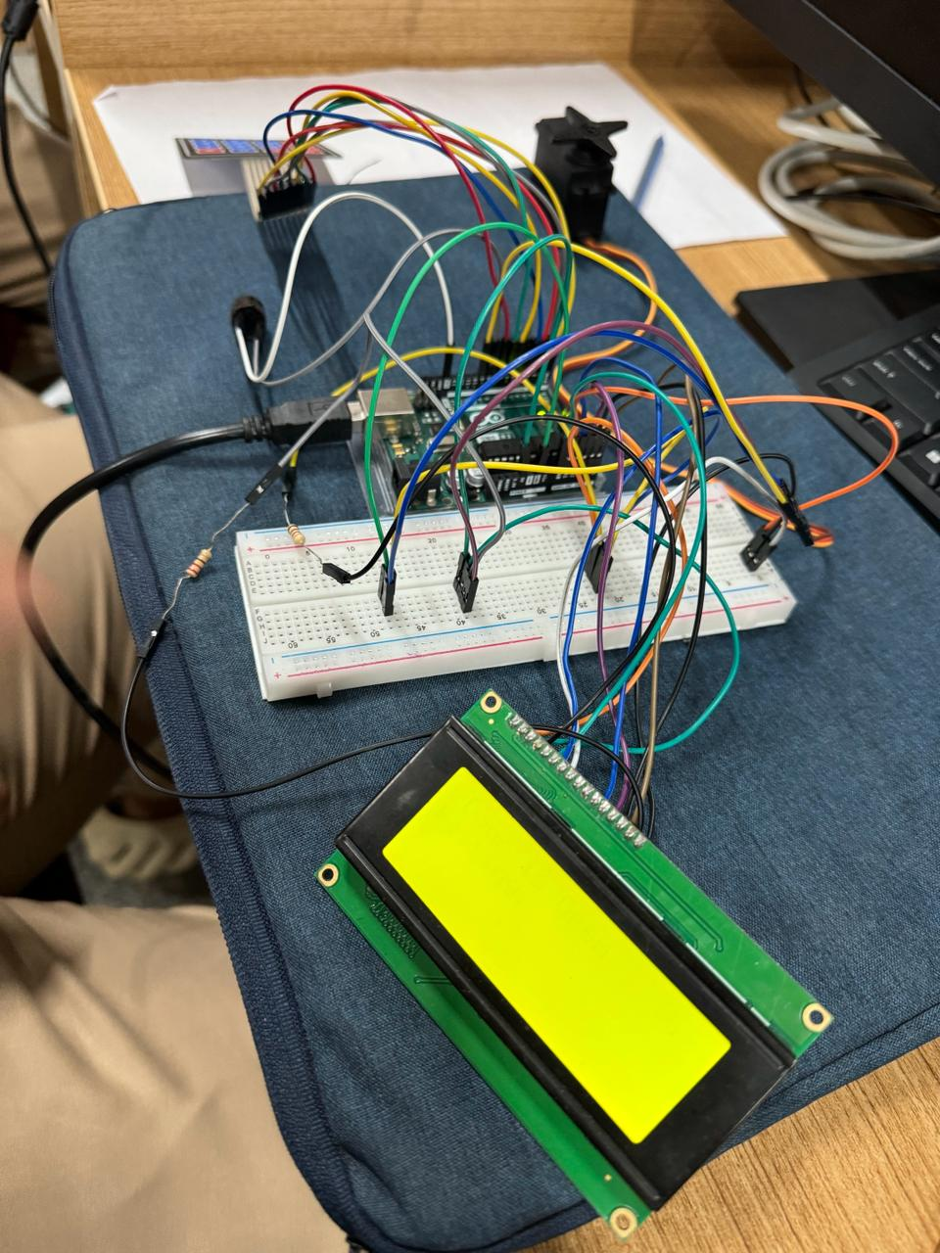

After running: 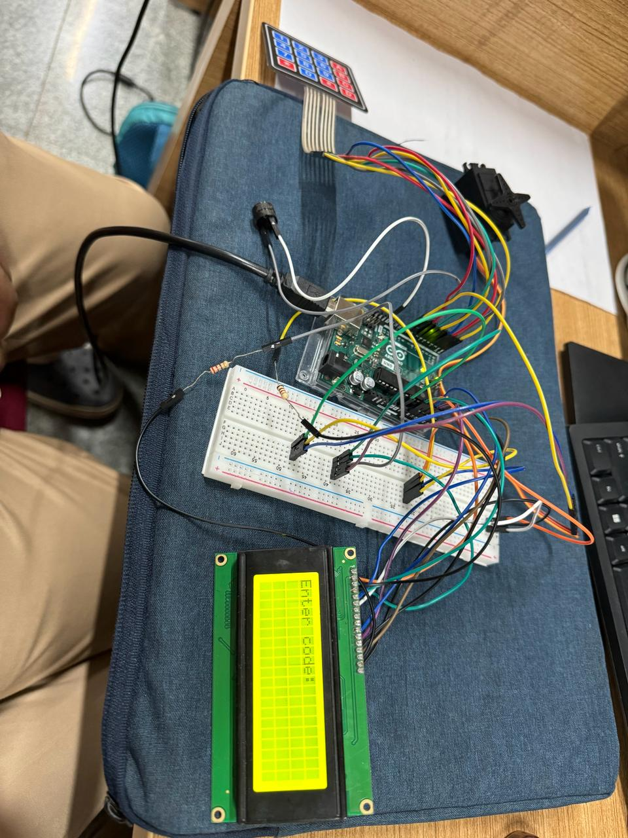

**Conclusion:**

In conclusion, the development and successful implementation of the home intrusion detection system using Arduino technology mark a significant advancement in home security solutions. This innovative system offers users a comprehensive solution for protecting their homes and belongings, enhancing safety, and providing peace of mind.

Through the integration of various sensors and actuators, the system effectively detects and responds to unauthorized entry attempts, alerts homeowners, and deters potential intruders. Features such as motion detection, door and window sensors, and audible alarms contribute to the system's robustness and effectiveness in detecting and preventing intrusions.

The home intrusion detection system represents a notable advancement in leveraging technology to address safety concerns and improve security measures. Its intuitive interface, intelligent detection algorithms, and responsive alerts set a new standard for modern home security systems.

Future Work:

While the current implementation of the home intrusion detection system has achieved commendable results, there are several promising avenues for future exploration and enhancement:

IoT Integration: Integrating Internet of Things (IoT) capabilities would enable remote monitoring and control of the intrusion detection system, providing users with greater flexibility and accessibility.

Machine Learning Algorithms: Incorporating machine learning algorithms could enable the system to adapt and optimize its detection algorithms based on historical data and evolving threat patterns, enhancing its accuracy and reliability.

Video Surveillance Integration: Integrating video surveillance capabilities could provide visual confirmation of intrusion events, enabling homeowners to assess the situation remotely and take appropriate action.

Enhanced Notification Systems: Upgrading the notification system with advanced features such as mobile app notifications, email alerts, or SMS notifications would improve the timeliness and effectiveness of alerts, ensuring prompt response to intrusion events.

Integration with Home Automation Systems: Integrating the intrusion detection system with home automation systems would enable seamless integration with other smart home devices, allowing for automated responses to intrusion events, such as activating lights or locking doors.